DM2112: Project Research A 24/25 (S1)

RSA Case Study

Can video games help communities?

Name: Oliver Edward Lund
Student ID: 2200980

Word Count: 4394

List of Figures:

Figure 1: Silent Hill 2

Figure 2: Resident Evil 7 Biohazard

Figure 3: Question 1 with responses from my Google Form Questionnaire.

Figure 4: Question 2 with responses from my Google Form Questionnaire.

Figure 5: Question 3 with responses from my Google Form Questionnaire.

Figure 6: Question 4 with responses from my Google Form Questionnaire.

Contents:

Contents 1
Introduction: 2
Methodology: 4
Research Planning: 5
Literature Review: 7
Findings: 8
Analysis: 12
Solution Proposal: 13
Conclusion: 14
Recommendations: 15
References: 16
Bibliography: 17
Appendices: 18
Appendix 1: 18

[1]

Introduction

How can you teach people through creative communities? I plan to help develop a horror game based on games such as Silent Hill 2 and Resident Evil 7 Biohazard. I will develop this game in a way that will help teach people aspects of the game that will help the audience develop further through the game and learn skills, such as how to solve puzzles within the game, which can include real-life elements such as math, English and much more. Whilst also creating a game that is accessible to all communities. This is the basis of my framework and the stepping stone that will help to get my game off the ground it plays an essential part in my framework.

Why I have chosen to do this because I have always been passionate about video games and have always wanted to help teach people new skills whilst also helping to develop something new that can help bring communities together and open up to their new careers in game development through the inspiration of my game.

When thinking about my game, I thought that it should be more inclusive and open to other people, such as members of the LGBTQ+ community as Lavender Magazine has reported, “LGBTQ+ games help the medium explore a wider range of the human experience”. They have also said games can help people come to terms with their sexuality. Games can be just or more inspirational than movies and TV, so it is of great interest to help games develop in a way that can bring communities together. (Lavender Magazine, 2024).

[2]
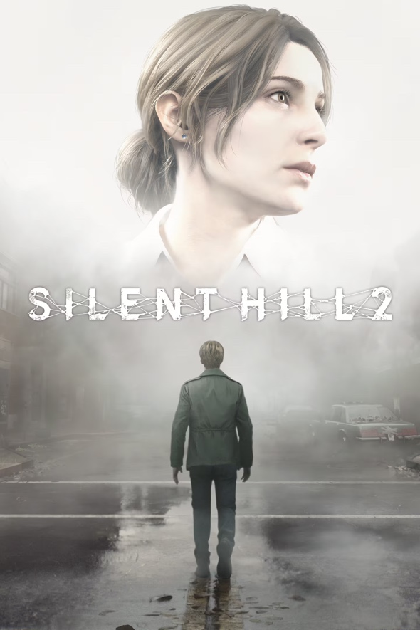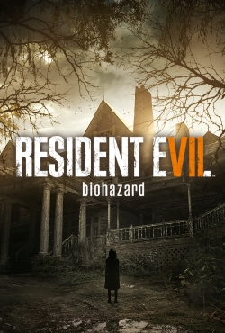
Figure 1: Silent Hill 2 Figure 2: Resident Evil 7 Biohazard

Aims and Objectives:

- Aim 1: research how to make your game appealing to your audience. Objectives: Learn how to make your game appealing to your audience and make it accessible to people no matter their disabilities.

- Aim 2: research your audience and your personality traits. Objectives: Do research into your key target audience and also research the personality traits you are thinking of implementing in the game to get a better understanding of your audience.

- Aim 3: look at technology and workflow. Objectives: Look into the technology that you would be using to create your game and look into the steps needed to help create your game.

- Aim 4: prototyping and feedback. Objectives: Think of ways you can prototype your game and get feedback from your audience so you can learn more from your audience and develop your game further.

[3]

Methodology

Introduction:

There are a couple of ways that I am considering to approach this, and that is either through Google Forms or through playtests, and I am going to use a qualitative type of research for secondary and primary. I understand that the two approaches are rather different Google Form is a simple questionnaire that can be shared around across many platforms, and playtesting is when you ask questions after people have played an early draft of your video games.

Both of these ideas of gaining feedback are useful as they help to give me a greater understanding of what my audience liked and disliked about my game and ideas. Secondary and primary research is very important: secondary research is very important as it helps to showcase that you are trying to learn more about your course and helps to show the audience how you have managed to achieve your goal, which, for me, is creating my game. Primary research is also very important as you need to get feedback from others to better understand what needs to be done and improved upon and what your audience likes and dislikes.

Methods:

I will also be using Google Forms to receive feedback from my audience, as this is a good way of getting feedback this is a tool that I have used before and find easy to share with others.

[4]
Research Planning

When creating a project such as this, I like to create a timetable to help me keep track of what I need to do and also help remind me as to what I need to do, when I need to do and when it needs to be done by below is the timetable that I created to help me keep track and stay on top of my work.

Below is a timetable showcasing my research planning that helped lay out what I needed and what days I had to research it. It also explains what I got from doing research and what I learnt. This was all to help give me some structure and help to provide me with a greater understanding of what I needed to do and when I needed to do it. The deadline was to get this done before this essay was due for handing in, and this timetable gave me an understanding of what I had to learn before then.

[5]
Monday | Tuesday | Wednesday | Thursday | Friday | Saturday | Sunday
PlayStation Blog: | Stages of developing a game: | Reddit: | Playtesting and Feedback: | How to make a game inclusive: | Technology and Workflow | My audience and personality traits
Through researching the PlayStation blog, I have learnt ways on how to keep audience updated and intrigued in the development process of my game. | I learnt as to what the necessary stages of developing a video game are and how digital media plays a role into the development process of a video game. | I learnt through reddit and through interacting with people online as to what keeps an audience interested in a game such as mine and how to keep it appealing. | I learnt as to how to develop a playtest session and other ways of how to get feedback from my audience. | When researching the web on how to make a game inclusive I learnt 5 key steps as to how to make my game inclusive and implemented and explained those 5 key steps in my case study. | I learnt as to what technology is used to develop a game such as what Game engines such as Unity and Unreal Engine 5 are used to develop a game, and which ones are most commonly used. Through research I also learnt the workflow of developing a game. | I learnt more about my target audience which will most likely be people of 18 and over and what appeal to them in a video game. I also did some research into personality traits and what emotions such as anger are and what causes them.

[6]
Literature Review:

Primary Research:

The questions and answers I have received from my Google Questionnaire. The responses were quite positive, which I was pleased about. Besides, the one that was not so positive was the one about this not fitting into my RSA Brief all too well. So, what I did was I tried to think of ways to fit this into my RSA Brief. I looked into ways my game could talk about. When going over the RSA Brief again, I saw how these games need to teach people and open up careers for people that is why I did some research as to how my game would be able to teach people when researching, I learned how to teach people how to play my game and incorporated it to be a way of teaching that fit into the brief.

What I used to teach me how to make my game seem like it could teach people was that I researched through the internet how to make in-game tutorials so that I could use that knowledge to teach my audience how to play games the website I used for my research was Medium where had a “step-by-step guide to making an in-game tutorial”. I will use the knowledge I have gained from this page to help make my game fit more into my brief. (Medium, 2022)

Also, to help make my game fit into my brief more, I had the idea that to make this more open to games, I thought that, hopefully, developing this game and releasing it would inspire others to develop games, opening new careers for everyone. I also tried to incorporate that with this game being inclusive; it helped to make anyone, no matter their background, feel like they could work with games, opening careers for everyone.

[7]

Findings

All my findings and secondary research have been done through the internet I have been researching key features of the development of video games and researching my audience, I also have been researching personality traits/emotions as that will be a key feature in my game I have also done a great deal of research into how make my game in some ways teach their audience and how making a game can open up careers for other people in the future.

Aim 1: research audience.

I have been researching how to make a game that appeals to my audience, which is gamers, typically teen adult gamers. What I have found on a website called Game Developer is there are five steps to creating a game that can appeal to audiences:

As quoted from the website, here is a summary of the five steps with a greater explanation down below:

- “Accomplishment: Appeals involving extrinsic and intrinsic rewards.”
- “Imagination: Appeals involving pretending and storytelling.”
- “Socialisation: Appeals involving friendly social interaction.”
- “Recreation: Appeals for adjusting physical, mental, or emotional state.”
- “Subversion: Appeals involving breaking social or technical rules.” (Game Developer, 2012)

Step 1: Accomplishment: Create a trophy/achievement style system that gives the audience a sense of accomplishment when progressing further through the game, makes them want to continue further through the game, and gives the game some replayability value, making the game seem longer.

Step 2: Imagination: Leave some of the imagination to the audience, I integrated a design your character system so the audience can use their imagination to create a character that appeals to them this will help to keep the audience integrated and feel like they are in control of some of the games key design elements.

[8]
Step 3: Socialization: Make there a sociable feature within the game so the audience can interact and socialise with other players. I can try and implement a feature where they can play the game with other people to keep people engaged in the game and want to play with their friends.

Step 4 Recreation: There should be some recreation implemented into the game to help keep the audience engaged my idea for recreation was changing the story depending on what personality trait the audience chooses at the start of the game, that way, the audience can recreate the game in any way they want to this helps to keep them engaged and interested.

Step 5 Subversion: Through the research I have done, it says another way to keep audiences is through breaking the social and technical rules of the game. My idea of implementing this into my game would be through allowing people to mod the game in the PC version, as modding is a very popular thing to do in the gaming community.

Aim 2: research personality traits.

For my game, many personality traits change the story in many ways to help keep the audience engaged and interested in the story of the game. I have done some research into the personality traits that I am considering implementing into the game, and here is what I have found.

“About Loneliness
Many of us feel lonely from time to time. Feelings of loneliness are personal, so everyone's experience will be different. Some people describe loneliness as the feeling we have when our need for social contact and relationships isn’t met. But loneliness isn’t the same as being alone. You may feel content without much contact with other people. But others may find this a lonely experience. Some people may only feel lonely at certain times. However, some people may experience chronic loneliness”. (Mind, 2023)

[9]

“What is anxiety?
Anxiety is what we feel when we are worried, tense or afraid – particularly about things that are about to happen or which we think could happen in the future. Anxiety is a natural human response when we feel that we are under threat. It can be experienced through our thoughts, feelings and physical sensations. Most people feel anxious at times. It's particularly common to experience some anxiety while coping with stressful events or changes, especially if they could have a big impact on your life.” (Mind, 2021)

“What is anger?
We all feel angry at times – it's part of being human. Anger is a normal, healthy emotion. There are many different reasons why we might feel angry. We may feel anger at having been treated badly or unfairly by others. Our anger may be a reaction to difficult experiences in our daily lives, our past, or in the world around us. Or it may be a way to cope with other emotions. For example, we may feel anger alongside feeling attacked, powerless, embarrassed or scared.”
(Mind, 2023)

“The Psychology of Fear
Fear is both a natural emotion and a survival mechanism. When confronted with a perceived threat, the body responds in specific ways. Physical reactions include sweating, increased heart rate, and high adrenaline levels that cause extreme alertness. This physical response is also known as the fight or flight response, with which your body prepares to confront the danger or run away. This biochemical reaction is likely an evolutionary development—an automatic response that is crucial to survival.” (Very Well Mind, 2024)

Aim 3: look at technology and workflow.

I have been looking at technological devices to use to help with my work and have been looking at game engines; there are many game engines to choose from the best game engines to use when developing a video game can range from Unity, Unreal Engine, Godot, and CryEngine; the game engines that I am most familiar with are Unity and Unreal Engine, and Unreal Engine is a game engine that I have some experience in using so I will use this one to help develop my game in the future.
There are also many apps I can use to design my games, such as Photoshop and Illustrator these are popular design apps that I have done a great deal of research on and have used many times.
[10]
I also researched the workflow of game development so I can see what the necessary steps are taken to successfully make a game successful. This one article I found on cgspectrum explains how video games are made and the game development process it talked about three key steps:

1: Pre-production

Pre-production depends on key factors such as how big you want your game to be; the bigger the game, the longer it’s going to take to make. Pre-production is the fundamental basis when it comes to making a game; it lays the ground for what’s to come. Pre-production also includes prototyping, which is a test that helps to test the game’s functionality, game mechanics, user experience, and art direction.

2: Production

Production is the longest stage in game development; production can take years. Production is where you refine your story, characters and environments. There are five key steps of progression when it comes to production: a prototype, first playable, vertical slice, pre-alpha, alpha, beta and gold master.

3: Post-production

After production is completed, you go into post-production this is where the fixing of the game comes into play. Post-production primarily consists of fixing bugs / creating patches to help the game work better and run smoother for the audience.

Aim 4: prototyping.

Aside from the feedback from Google Forms, I thought another good way to get feedback was by prototyping my games and letting people do playtests of my game. I have read an online article explaining how to get great playtesting feedback. This article by Game Developer helped to give me a greater understanding of how to do playtesting successfully. (Game Developer, 2016)

[11]

Analysis

Through my research, I have found and figured out a way to come up with a game that can be useful for communities and bring them closer together I have also learnt how to develop my game in a way that cannot be deemed offensive and can greatly appeal to the audience in many aspects helping all communities which they can hopefully find entertaining. My findings helped to influence my practical project into being more grounded and helped me learn how to make my game stand out more, which was a key influence on my practical project. The insights of my research also helped to address the environmental challenge of my development decisions in ways that made me constantly change my development decisions to help make them fit into the brief more.

My findings also aligned with my RSA brief goals and the sustainable development goals as my findings helped teach me how to make my game teach people by putting in-game tutorials and also helped to give me a clearer understanding of how to make my game open to all kinds of people in hopes of opening new careers for them and inspiring them to do game development. My research also helps to contribute to broader social challenges as it helps to give me an understanding of how to make my game more open to different kinds of people.

Audience:

The research that I had found for forums and communities online also helped me get closer to what appeals to gamers and what they want out of a game this info helps me understand what kind of solutions I could use to make my game appeal more to my key demographic audience.

Forms and feedback:

My understanding when analysing what feedback had been given to me was that I found out my audience didn’t think that my game linked back to the RSA brief, I changed It so it will now have multiplayer and help teach people through in-game tutorials. The audience did like the concept of my game, though, and the simple UI design as well, although they found it to be quite basic.
[12]
Solution Proposal

My answer to the question of whether video games can help bring communities together, teach people, and open up careers for other people is yes. Video games can help to bring communities together if done correctly. The three key steps that I have come up with when designing a game meant to bring communities closer together are 1: make the game design very simple and an in-game tutorial to help with the teaching aspect of the brief and help teach people how to play my game. 2: make the game accessible to everyone, this means releasing the game on PC and console; that way, more members of your audience can access your game, giving you also a bigger audience to appeal to. 3: Listen to what your fans have to say and regularly update the game to help fit your audience’s needs and keep your game working.

Those three steps that I mentioned are good solutions for games in general, but when it comes to games, helping bring people and communities together is one key step, and that is implementing something that appeals to everyone, whether that is making them design their character so they can relate and feel more connected to the game or it could be as simple as making the game multiplayer that way people can communicate and interact with each other. The simpler your idea, the better that way, it doesn’t leave your audience confused and brings everyone in your audience closer to the game, making this a wholesome community.

[13]
Conclusion

To conclude, ultimately, my understanding of how to develop a successful game that meets everyone’s needs has become much greater and has certainly been met in that way. My research has hopefully helped to create something that can truly bring people closer together and make a difference in communities all over the world and enjoy having something in common.

If I had to redo the case study, I would have changed a few things. I started by changing my discussion about the PlayStation blog I implemented some blog posts to help showcase what I am referring to and give the audience a greater understanding of what exact PlayStation blogs I am talking about.

I would also have looked at different blogs from different companies instead of just PlayStation to add a new layer of depth to my research and case study. I would have also liked to add some responses that I had received from my playtest and Google forms. That way, I can also explain how I improved my game after receiving these responses, which would help establish how I respond to my audience.

Through the research and development my game has gone through, I have always set the sustainable development goal 3 first, ensuring that this game is promoted in a way that helps with the well-being of all lives and ages. The game in itself promotes well-being in all lives through the way that the story is portrayed, with the personality traits, for example, this game helps represent people struggling with mental disabilities and anxiety to help make members of the audience who struggle with understanding that. They are not alone, that is the way I have made my game to follow the sustainable development goal 3.

[14]
Recommendations:

The suggested action after these insights is to develop a game that not only appeals to everyone and makes everyone feel as if they are welcome but also teaches people in some respects and hopefully inspires and opens up new career opportunities for people. This research has helped to give me a greater understanding of how to do that, and that is what will be done.

I will further my investigation into the development of video games as I feel that it will be useful information for the other case studies and will help teach me more about my interests in game development.

Based on my findings, what I would do to test my RSA solution would be to create this game and then hopefully get people a chance to play it so that I can see more of whether or not people like this game and if they think that it has taught them something and if they have enjoyed the game or not. Playtests are a very successful and well-known way of testing, and that is why I think that it will be a very good practical project.

[15]
References

Reed, A. (2024) Why LGBTQ+ Games Matter, Lavender. Available at: https://lavendermagazine.com/featured-home-page/why-lgbtq-games-matter [Accessed 28 October 2024].

Tocci, J. (2012) Five Ways Games Appeal to Players, Game Developer. Available at: https://www.gamedeveloper.com/design/five-ways-games-appeal-to-players [Accessed 30 October 2024].

Mind (2023) Loneliness. Available at:
https://library-guides.ucl.ac.uk/harvard/missing-details [Accessed 10 November 2024].

Mind (2021) Anxiety and Panic Attacks. Available at: https://www.mind.org.uk/information-support/types-of-mental-health-problems/anxiety-and-panic-attacks/about-anxiety [Accessed 10 November 2024].

Mind (2023) Anger. Available at: https://www.mind.org.uk/information-support/types-of-mental-health-problems/anger/about-anger [Accessed 12 November 2024].

Fritscher, L. (2024) The Psychology of Fear, Very Well Mind. Available at: https://www.verywellmind.com/the-psychology-of-fear-2671696 [Accessed 14 November 2024].

Tomatis, I. (2024) PlayStations Black Friday Deals 2024, PlayStation Blog. November 20. Available at: https://blog.playstation.com/2024/11/20/playstations-black-friday-deals-2024 [Accessed 20 November 2024].

Reddit (2021) What Makes a good game? Available at: https://www.reddit.com/r/gameideas/comments/uegpxf/what_makes_a_good_game/?rdt=58274 [Accessed 21 November 2024].

Vitkunas, S. (2022) Learning to Teach: A step-by-step guide to making an in-game tutorial, Medium. Available at: https://medium.com/mighty-bear-games/learning-to-teach-a-step-by-step-guide-to-making-an-in-game-tutorial-d58b0c98288a [Accessed 23 November 2024].

Wiltgren, F. (2016) A Simple Way to get Great Playtesting Feedback. Available at: https://www.gamedeveloper.com/design/a-simple-way-to-get-great-playtesting-feedback [Accessed 25 November 2024]

[16]

Bibliography

PlayStation Blog:

I used the PlayStation Blog as a way to research my audience I looked at some of the news that they had posted to get a greater understanding of what is a good way to keep my audience updated with news about my game and updated on the progress of my game’s development process.
One of the PlayStation Blog posts that I looked at was talking about the Black Friday deal though it is not entirely relevant to game development, it helps to give me a greater understanding of how to keep in contact with your audience. The headline of the blog was: “PlayStation offers this Black Friday feature incredible savings on hardware, games, PlayStation Plus, and more”.

(Tomatis, 2024)

Reddit:

I looked into Reddit to get a closer understanding of what the public thinks would make a good video game. I read a Reddit post that explained what makes a good game to help give me a greater understanding of what to implement into my game and make it appeal to people. The headline of the post was “What Makes a good game?”.

(Reddit, 2021)

[17]
Appendices:

Appendix 1:

Here, you can view my questions in full. This questionnaire was shown to the classroom and filled out by seven people it was open to the class on the 20th of November 2024, and they filled it out using a QR code that was shown by my teacher, to who I had shared the form. All of the people who filled out this form were part of the University of Winchester. I used these answers to help and improve my idea and RSA brief as best I could. Although some of the answers were not what I was expecting, so I used those answers to help improve my RSA case study solution.

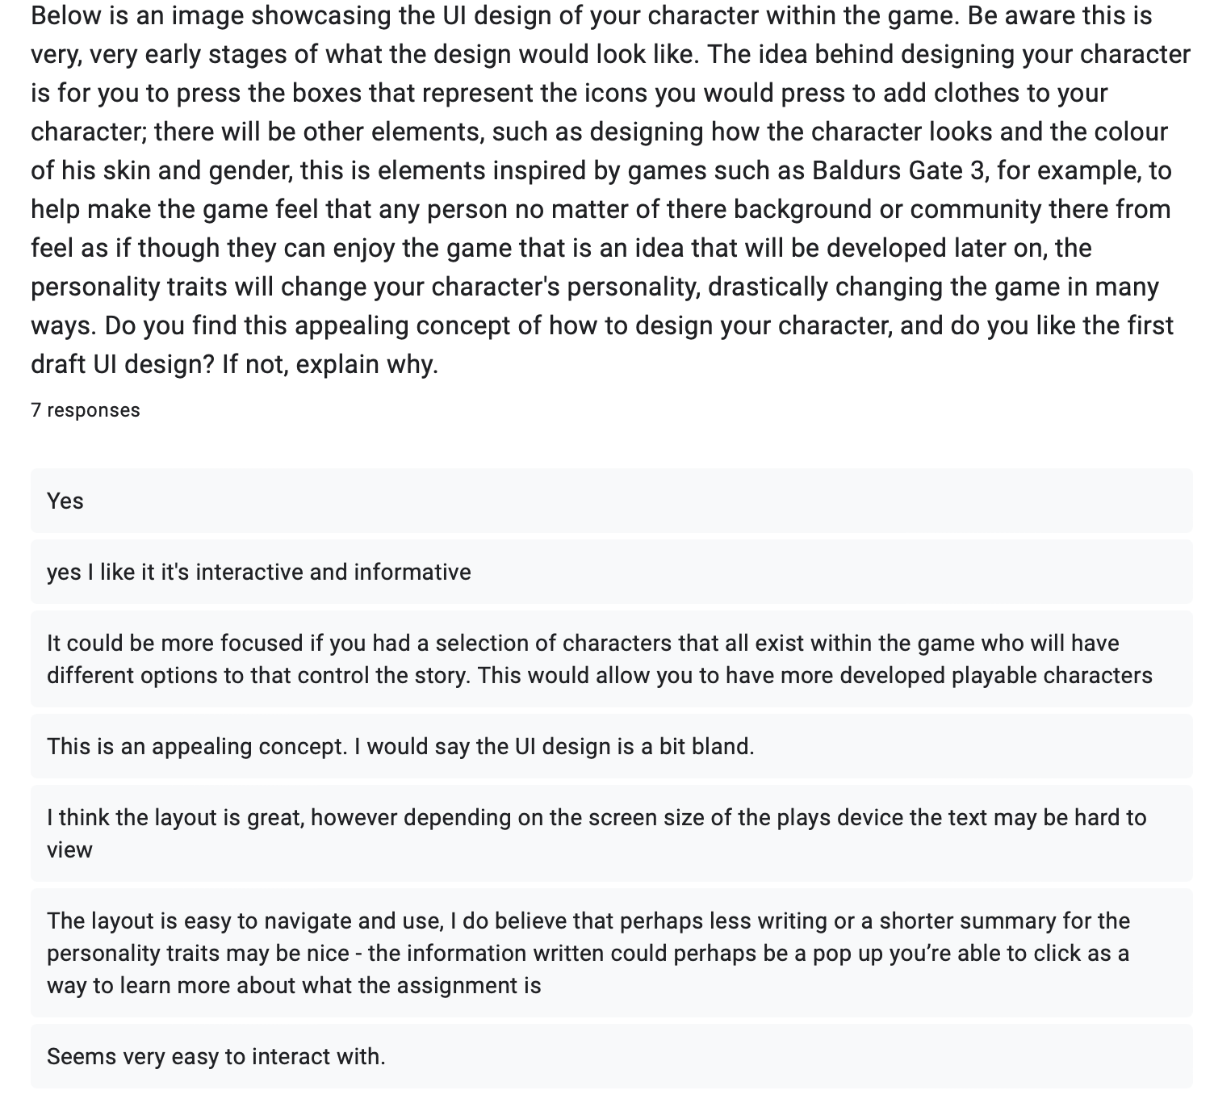
Figure 3: Question 1 with responses from my Google Form Questionnaire.

[18]
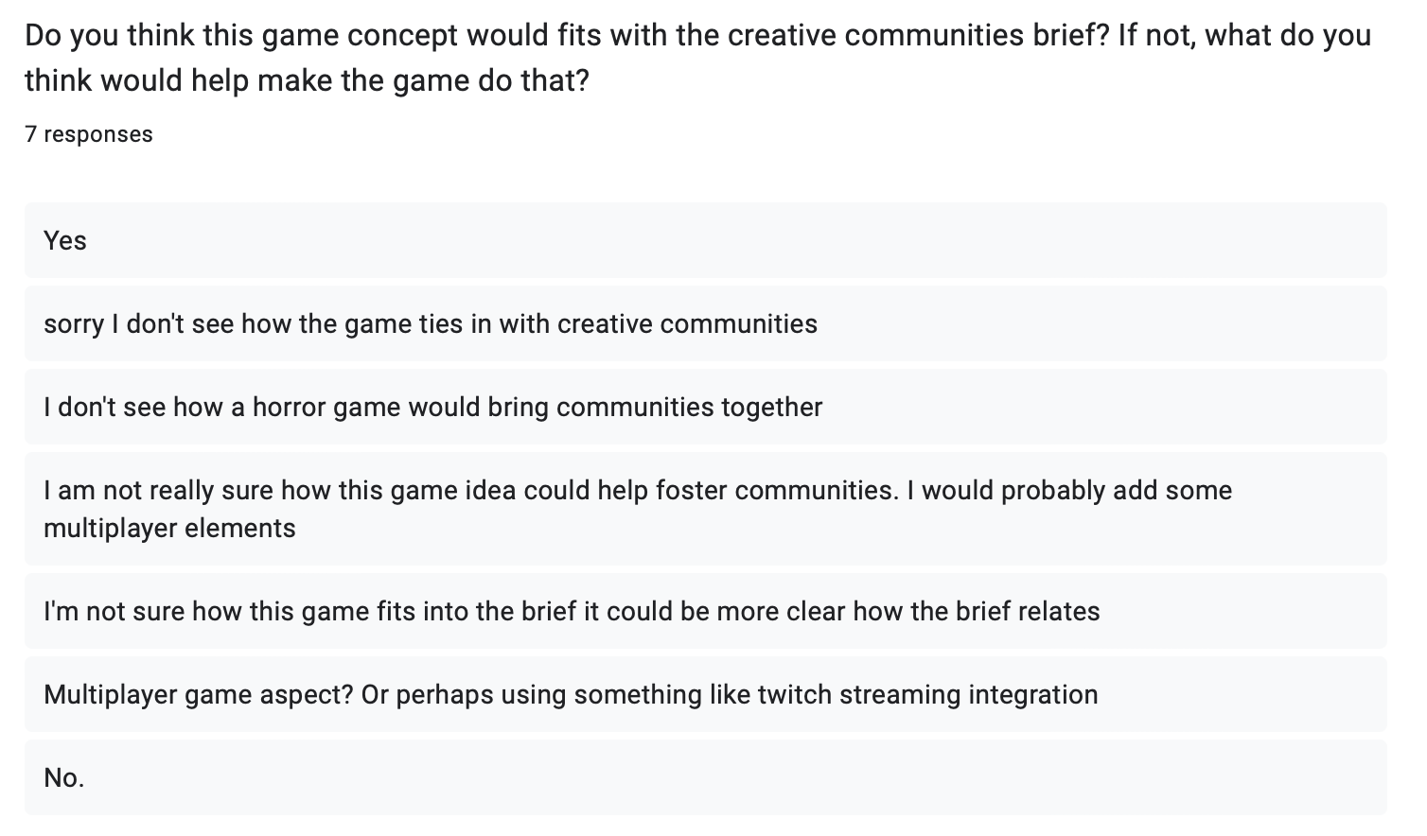
Figure 4: Question 2 with responses from my Google Form Questionnaire.

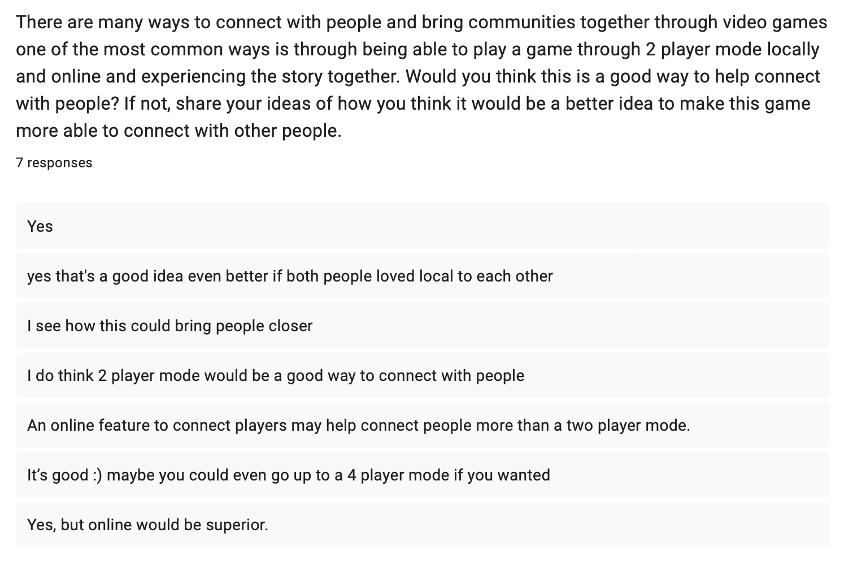
Figure 5: Question 3 with responses from my Google Form Questionnaire.

[19]
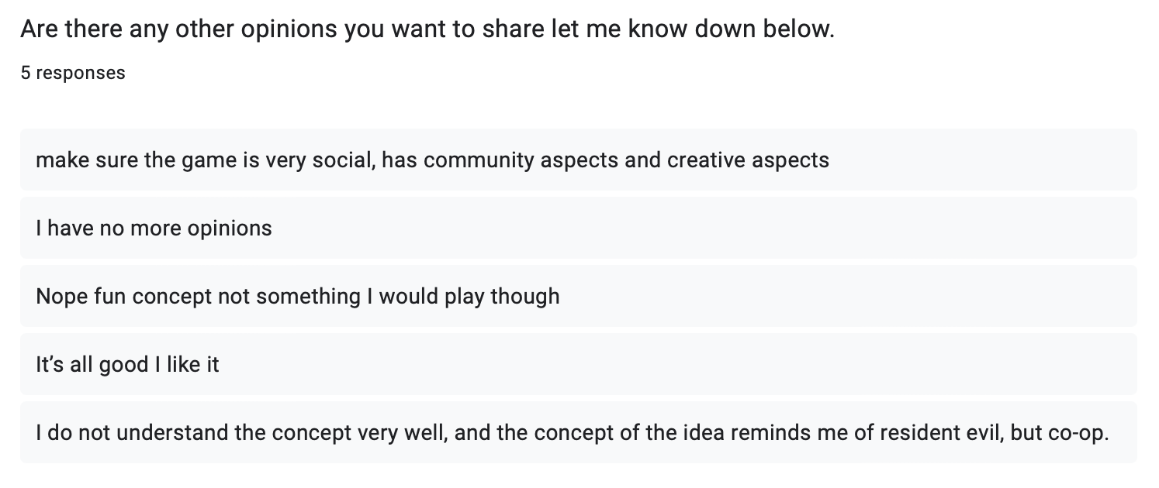
Figure 6: Question 4 with responses from my Google Form Questionnaire.

[20]

